Tirumala Reddy Konireddy

Lab 02 report

Sensor Data Collection and HBase Uploading and Retrieval

**Data Collection from BLE sensor Tag and Android Mobile device**

I had imported our tutorial program App1 –App3 GPS into our local Eclipse, which is able to write data about Accelerometer service from BLE sensor tag, present Date and GPS location of Android Mobile device. I had understood the code and methods related to enabling, reading and notifying different sensors of BLE sensor tag. I had developed that code to write Humidity, Temperature, Gyroscope and Pressure values of room using sensor tag services.

Please find my source files in my github :

<https://github.com/tkhgf/Big-data-lab02>

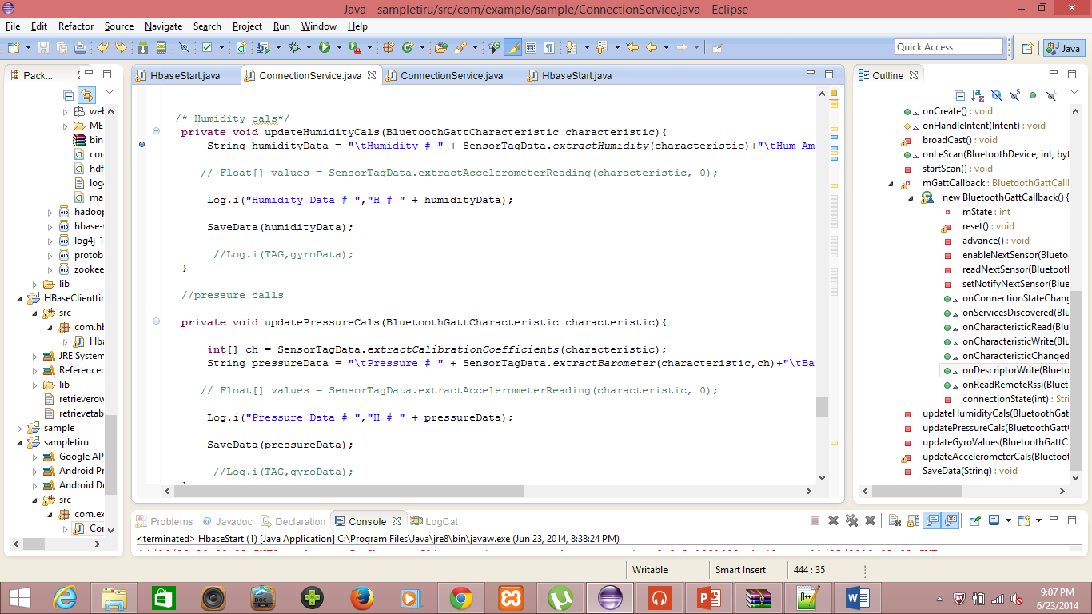

I had found the accelerometer, GPS , Humidity sensor enabling while running application in Android device as below.

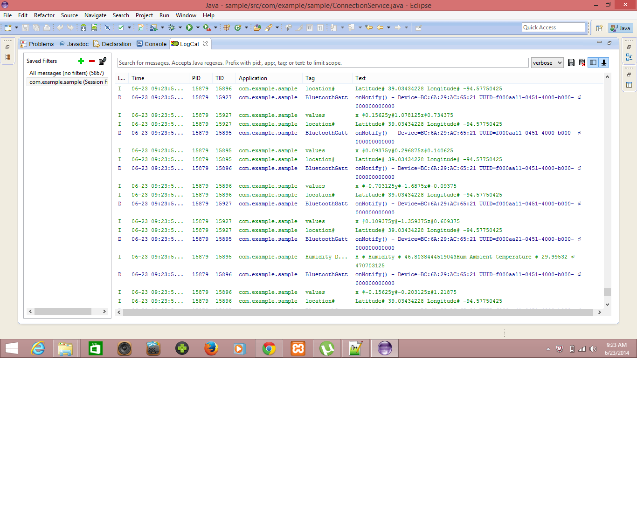

I had successfully written the Humidity and Temperature data along with the old data services as below.

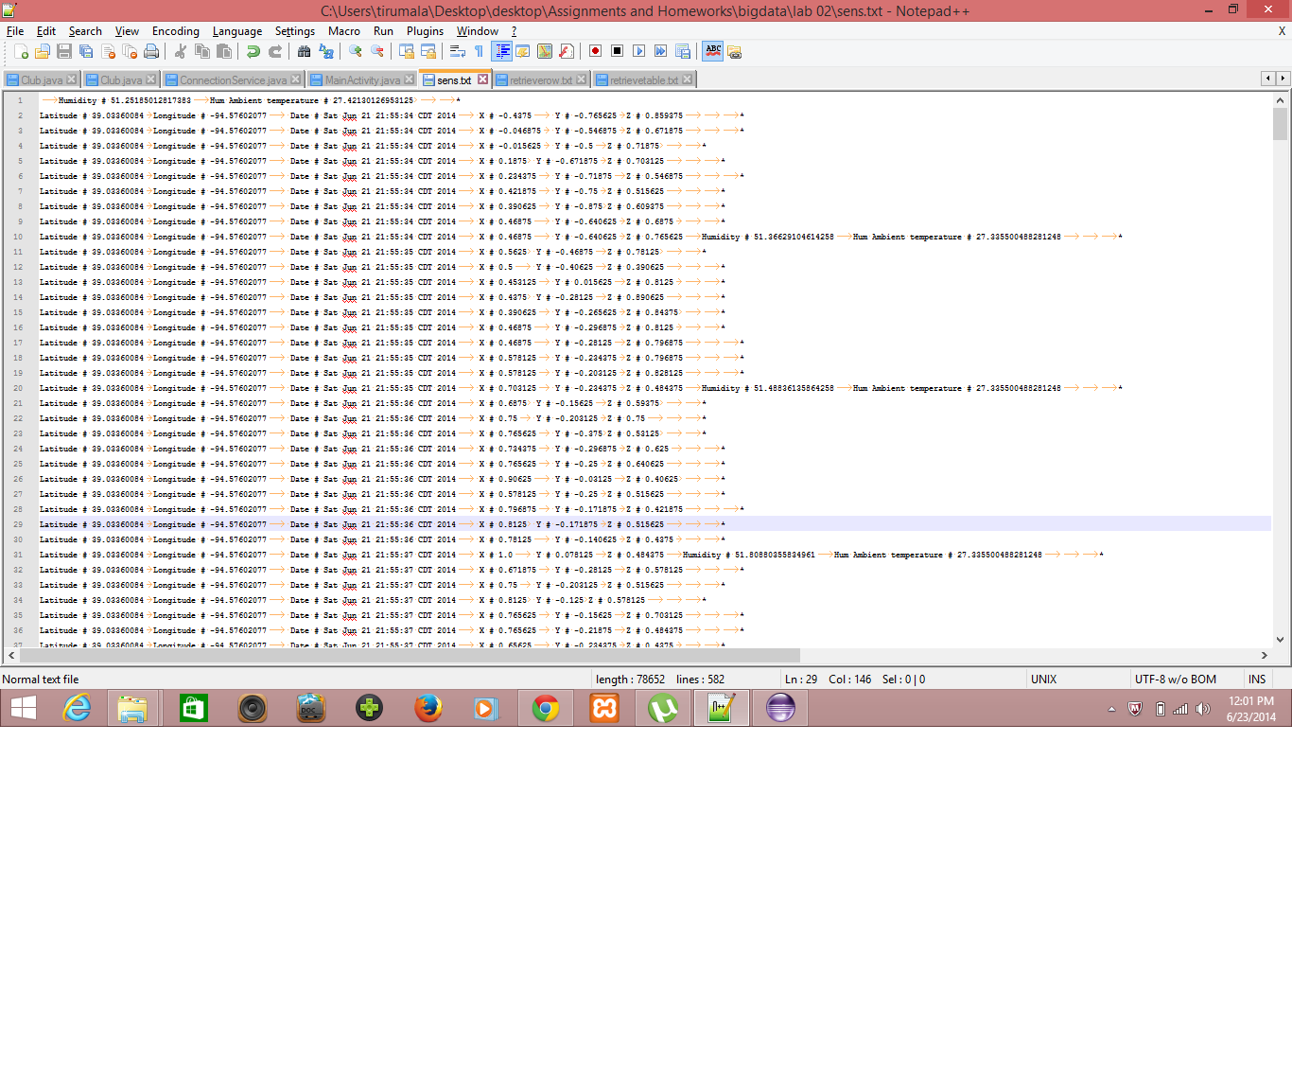

**Uploading Data to HBase**

Similarly as above, I had developed the Hbaseclient.java file to write my file into HBase table as below.

Please find my source files in my github :

<https://github.com/tkhgf/Big-data-lab02>

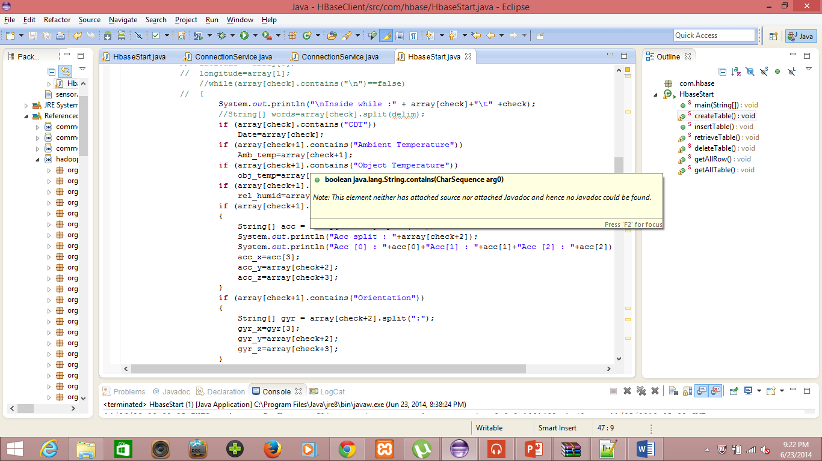

I had successfully created a HBase table of name Group1SensorTable, and insert data into that table.

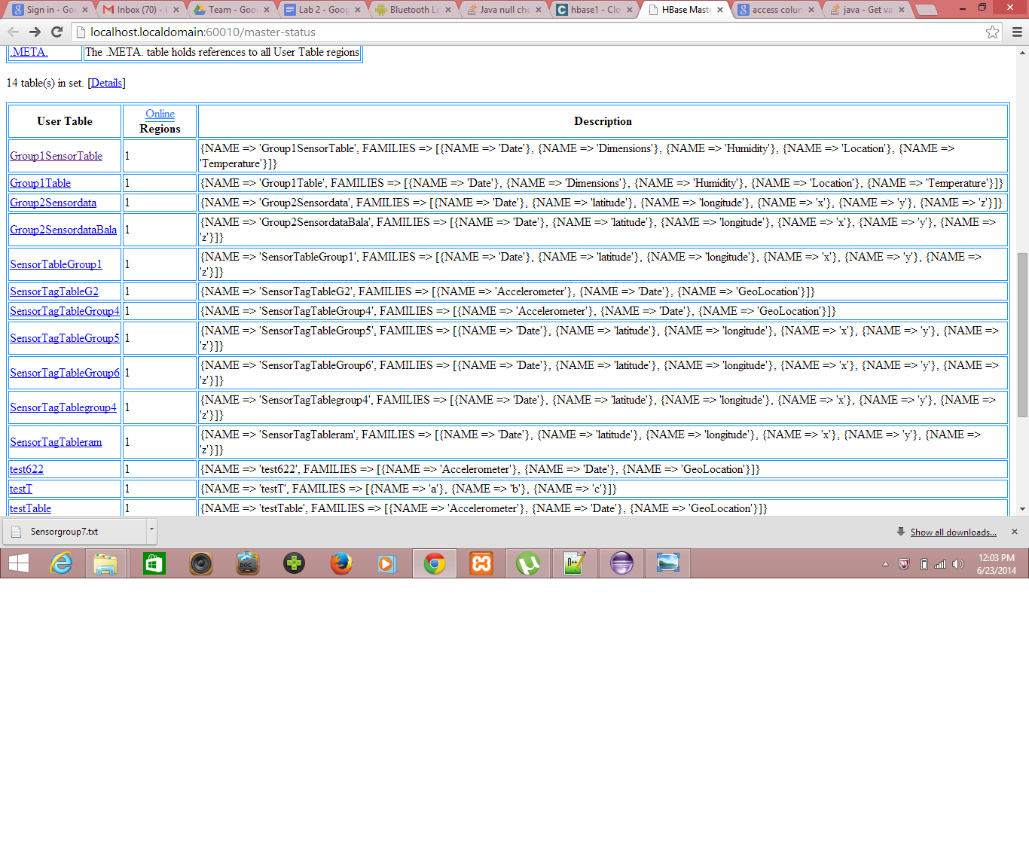

I had successfully retrieved 100 data entries using retrievetable() as below.

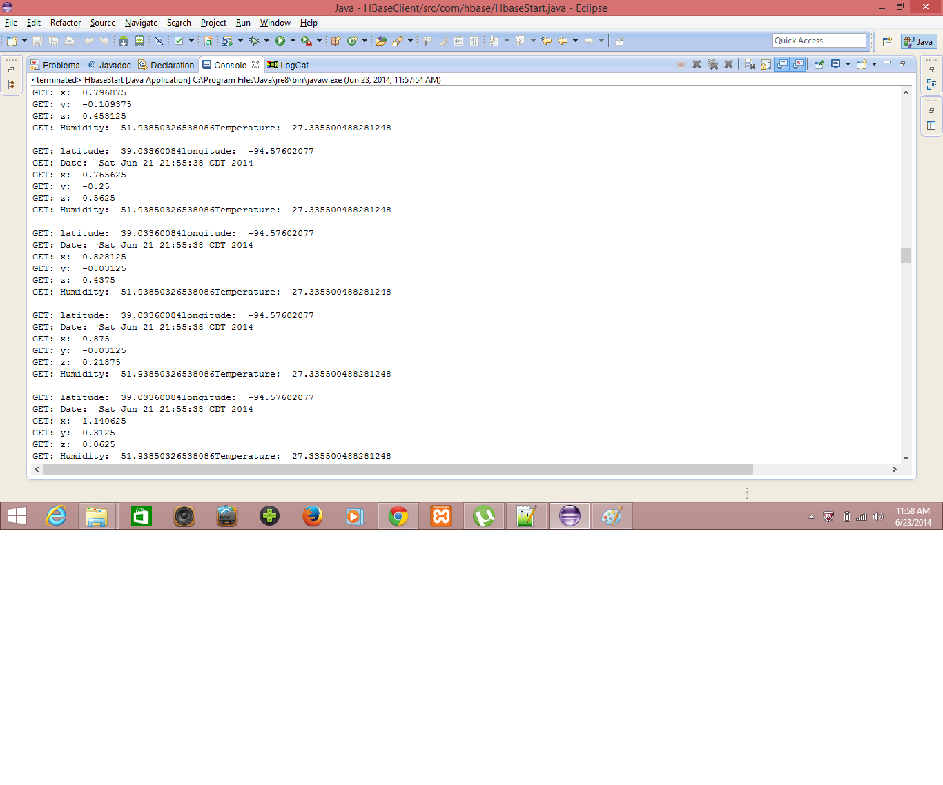

I had successfully retrieved all row entries using getallrow() as below, which I had written into a file named retrieverow.txt.

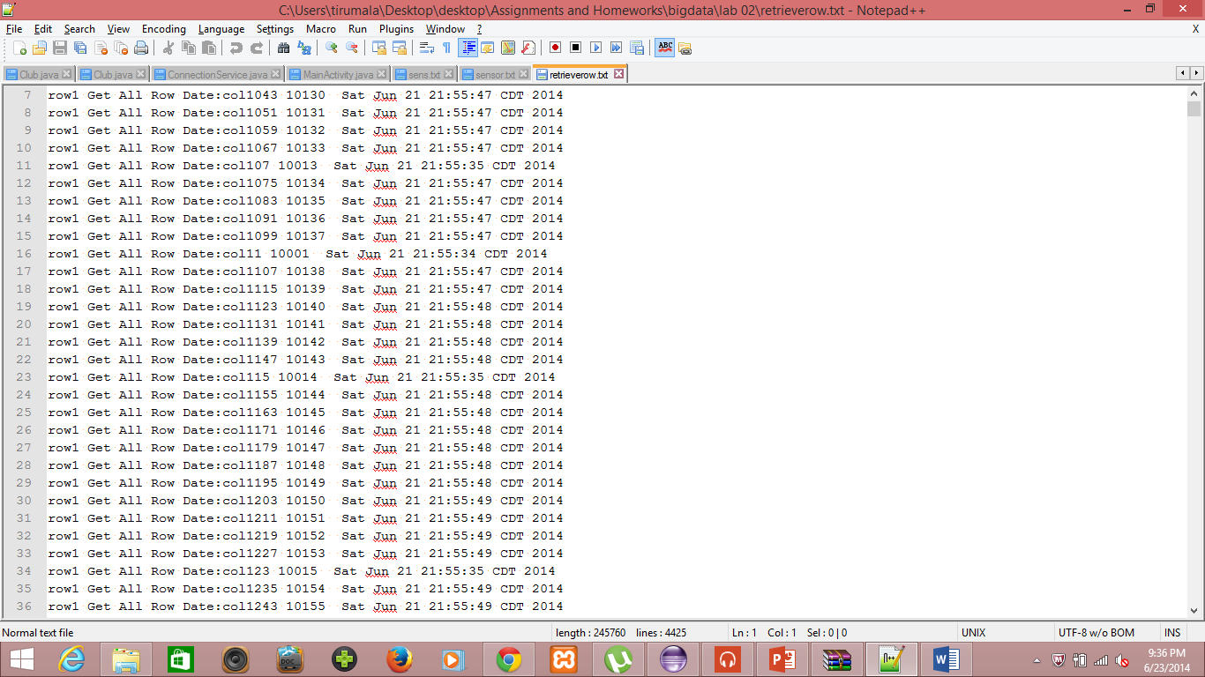

I had successfully retrieved all row entries using getalltable() as below, which I had written into a file named retrievetable.txt.

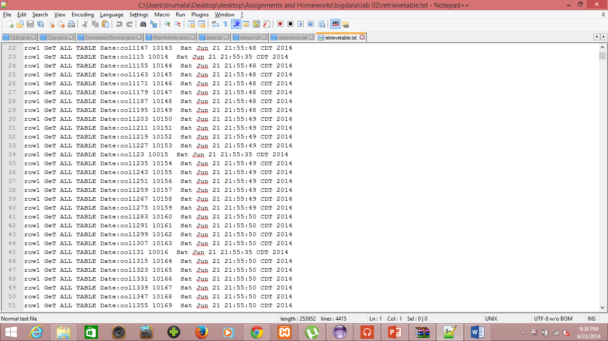

**The End**